三角形网络可编程光子链路的设计

*Aolong Sun*

除了矩形可编程光子链路，基于三角形网络的可编程光子链路同样得到了广泛的应用。这一部分主要详细讲解如何从单元元件MZI出发，基于PhotoCAD搭建三角形网络可编程光子链路。

目录

第一部分 构建MZI unit 1

第二部分 构建可编程三角形MZI网络 5

带有8个外置光学端口的MZI Mesh（MZI_triangle_mesh） 5

带有8个光栅耦合器的MZI Mesh（MZI_triangle_mesh_with_GC） 8

附录：基于comp scan进行批量化光栅耦合器连接 13

# 第一部分 构建MZI unit

在构建三角形网络之前，需要先补充gpdk里的单元器件。在这里我们选择构建一个单臂可调的片上集成马赫曾德尔干涉仪（MZI）。这一器件的可调性是通过PN结（电可调）实现的，当然也可以使用热可调的MZI来构建该三角形网络。

首先，导入库文件，在这里我们需要用到定向耦合器、直波导、移相器：

from dataclasses import dataclass

from typing import Tuple

from fnpcell import all as fp

from gpdk.components.directional_coupler.directional_coupler_sbend import DirectionalCouplerSBend

from gpdk.components.straight.straight import Straight

from gpdk.components.pn_phase_shifter.pn_phase_shifter import PnPhaseShifter

from gpdk.technology import WG, get_technology

定义网络的基础单元器件MZI类：

@dataclass(eq=False)  
class MZI(fp.PCell, band="C"):  
 p_width: float = fp.PositiveFloatParam(default=1)

n_width: float = fp.PositiveFloatParam(default=1)

np_offset: float = fp.FloatParam(default=0)

wg_length: float = fp.PositiveFloatParam(default=100)

arm_spacing: float = fp.PositiveFloatParam(default=60)

dc_length: float = fp.FloatParam(default=100)

waveguide_type: WG.FWG.C = fp.WaveguideTypeParam(type=WG.FWG.C)

pn_phase_shifter: fp.IDevice = fp.DeviceParam(type=PnPhaseShifter, port_count=2, pin_count=2, required=False)

straight_waveguide: fp.IDevice = fp.DeviceParam(type=Straight, port_count=2, required=False)

directional_coupler_left: fp.IDevice = fp.DeviceParam(type=DirectionalCouplerSBend, port_count=4, required=False)

directional_coupler_right: fp.IDevice = fp.DeviceParam(type=DirectionalCouplerSBend, port_count=4, required=False)

port_names: fp.IPortOptions = fp.PortOptionsParam(count=4,default=["op_0", "op_1", "op_2", "op_3"])

def _default_waveguide_type(self):

return get_technology().WG.FWG.C.WIRE

def _default_pn_phase_shifter(self):

return PnPhaseShifter(

name="ps", p_width=self.p_width, n_width=self.n_width, np_offset=self.np_offset,

wg_length=self.wg_length-10, waveguide_type=self.waveguide_type,

transform=fp.translate(5, 0)

)

def _default_straight_waveguide(self):

return Straight(

name="straight", waveguide_type=self.waveguide_type, length=self.wg_length, transform=fp.translate(0, -self.arm_spacing)

)

def _default_directional_coupler_left(self):

return DirectionalCouplerSBend(

name="dc_l", bend_radius=10, waveguide_type=self.waveguide_type, transform=fp.translate(-self.dc_length, -self.arm_spacing / 2)

)

def _default_directional_coupler_right(self):

return DirectionalCouplerSBend(

name="dc_r", bend_radius=10, waveguide_type=self.waveguide_type, transform=fp.translate(self.wg_length + self.dc_length, -self.arm_spacing / 2)

)

def build(self) -> Tuple[fp.InstanceSet, fp.ElementSet, fp.PortSet]:

insts, elems, ports = super().build()

# fmt: off

waveguide_type = self.waveguide_type

pn_phase_shifter = self.pn_phase_shifter.translated(-self.wg_length / 2, self.arm_spacing / 2)

straight_waveguide = self.straight_waveguide.translated(-self.wg_length / 2, self.arm_spacing / 2)

directional_coupler_left = self.directional_coupler_left.translated(-self.wg_length / 2, self.arm_spacing / 2)

directional_coupler_right = self.directional_coupler_right.translated(-self.wg_length / 2, self.arm_spacing / 2)

port_names = self.port_names

ports += directional_coupler_left["op_0"].with_name(port_names[0])

ports += directional_coupler_left["op_1"].with_name(port_names[1])

ports += directional_coupler_right["op_2"].with_name(port_names[2])

ports += directional_coupler_right["op_3"].with_name(port_names[3])

insts += fp.Linked(

link_type=waveguide_type,

bend_factory=self.waveguide_type.BEND_EULER,

links=[

directional_coupler_left["op_3"] >> pn_phase_shifter["op_0"],

directional_coupler_left["op_2"] >> straight_waveguide["op_0"],

directional_coupler_right["op_0"] >> pn_phase_shifter["op_1"],

directional_coupler_right["op_1"] >> straight_waveguide["op_1"],

],

ports=[],

)

# fmt: on

return insts, elems, ports

在本案例中，MZI由两个定向耦合器、一个移相器以及一个直波导构成，基本结构如下图所示：

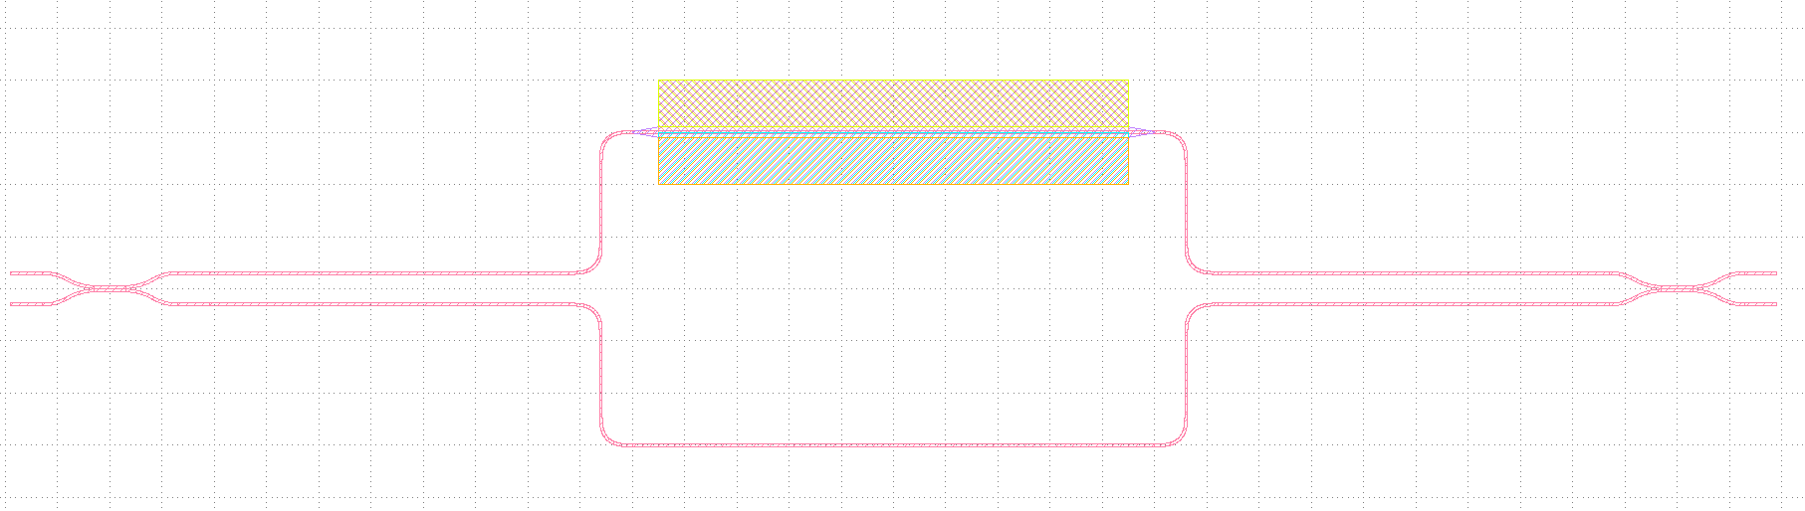

其中移相器基于PN结构建，通过改变施加到PN结两端的电压，即可改变载流子浓度，从而改变波导的折射率，最终改变相对相位。因此，通过改变电压，可以使MZI工作在不同的工作模式，如直通、交叉或耦合模式，如下图所示：

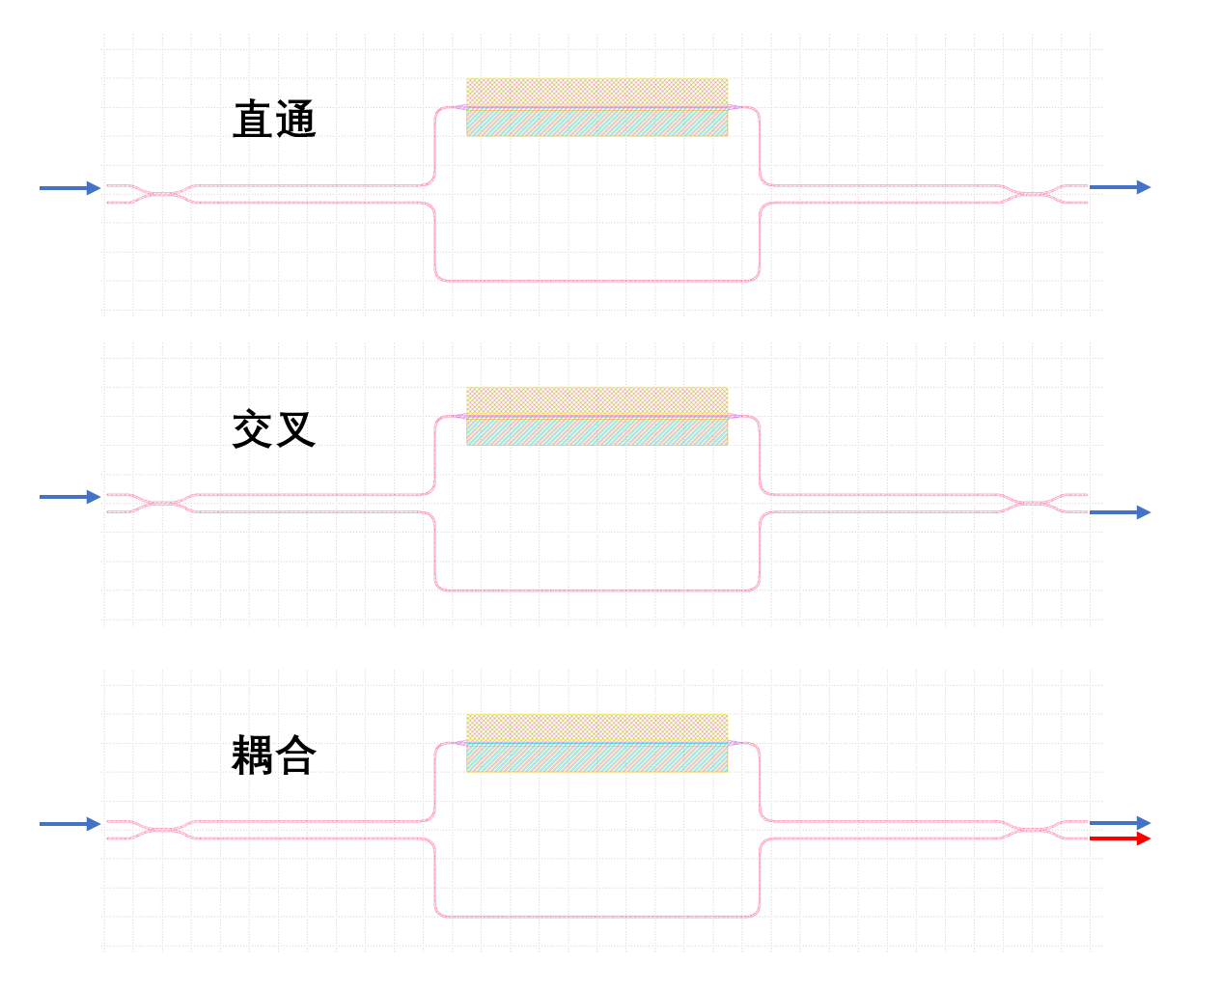

在本例中，依次构建四个单元器件并设置好位置参数后，可以直接使用PhotoCAD自带的Linked方法实现端口的自动连接。其次，需要给MZI分配四个端口并指定名称。注意，我们在class里对各个元件进行了平移，使整个MZI单元的原点位于MZI的中心处，如不这么做，在对MZI进行旋转操作时会出错，因为PhotoCAD里的旋转操作默认是以单元器件的原点为中心的。本例中MZI的原点位置如下图所示：

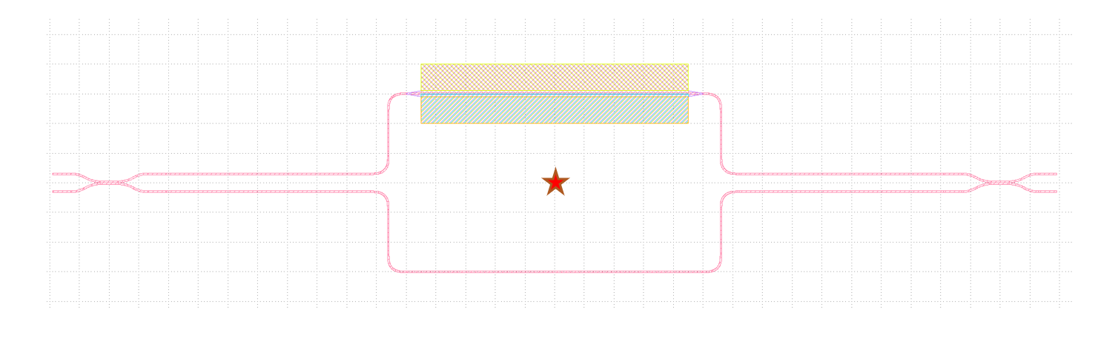

在主函数里调用MZI并生成gds文件：

if __name__ == "__main__":

from gpdk.util.path import local_output_file

gds_file = local_output_file(__file__).with_suffix(".gds")

library = fp.Library()

TECH = get_technology()

# =============================================================

# fmt: off

library += MZI()

# fmt: on

# =============================================================

fp.export_gds(library, file=gds_file)

fp.plot(library)

自动生成的版图如下：

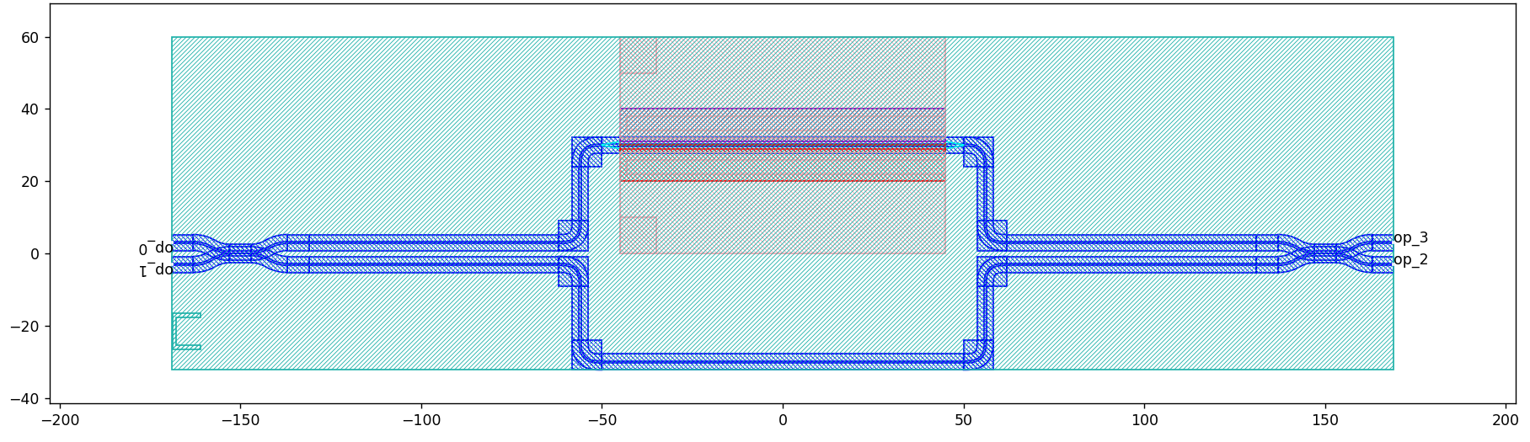

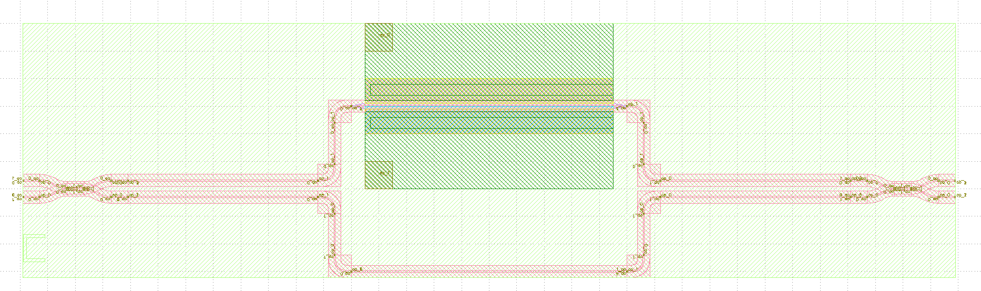

# 第二部分 构建可编程三角形MZI网络

在这一步里将调用上一步构建的MZI类，实现三角形MZI网络的构建。我们提供两种实现方案，一种是不加光栅耦合器的MZI网络，提供了8个外置光学端口（op0~op7），可以方便用户自定义拓展该网络；第二种实现方案是给MZI网络加上了8个光栅耦合器，构成了一个完整闭环的光子链路版图。

## 带有8个外置光学端口的MZI Mesh（MZI_triangle_mesh）

首先导入必要的库文件：

from dataclasses import dataclass

from typing import Tuple

from fnpcell import all as fp

from gpdk.components.mzm.mzi import MZI

from gpdk.technology import WG, get_technology

from gpdk.routing.extended.extended import Extended

from gpdk.technology.waveguide_factory import EulerBendFactory

from gpdk.components.grating_coupler.grating_coupler import GratingCoupler

from gpdk.routing.comp_scan.comp_scan import CompScan,Block

随后构建MZI_triangle_mesh类：

@dataclass(eq=False)

class MZI_triangle_mesh(fp.PCell, band="C"):

"""

Attributes:

p_width: defaults to 1

n_width: defaults to 1

np_offset: defaults to 0

wg_length: defaults to 25

arm_spacing: defaults to 100

dc_length: defaults to 100

waveguide_type: type of waveguide

pn_phase_shifter: instance of `PnPhaseShifter`, port_count=2, pin_count=2, required=False

straight_waveguide: instance of `Straight`, port_count=2, required=False

directional_coupler_left: instance of `DirectionalCouplerSBend`, port_count=2, required=False

directional_coupler_right: instance of `DirectionalCouplerSBend`, port_count=2, required=False

port_names: defaults to ["op_0", "op_1", "op_2", "op_3"]

Examples:

```python

TECH = get_technology()

mzi = MZI(wg_length=600, waveguide_type=TECH.WG.FWG.C.WIRE)

fp.plot(mzi)

```

![MZI](images/mzi.png)

"""

side_length: float = fp.PositiveFloatParam(default=400)

dc_length: float = fp.FloatParam(default=100)

arm_spacing: float = fp.FloatParam(default=60)

wg_length: float = fp.FloatParam(default=100)

waveguide_type: WG.FWG.C = fp.WaveguideTypeParam(type=WG.FWG.C)

MZI_unit: fp.IDevice = fp.DeviceParam(type=MZI, port_count=4, required=False)

port_names: fp.IPortOptions = fp.PortOptionsParam(count=8,

default=["op_0", "op_1", "op_2", "op_3", "op_4", "op_5", "op_6", "op_7"])

def _default_waveguide_type(self):

return get_technology().WG.FWG.C.WIRE

def _default_MZI_unit(self):

return MZI(arm_spacing=self.arm_spacing, dc_length=self.dc_length, wg_length=self.wg_length)

def build(self) -> Tuple[fp.InstanceSet, fp.ElementSet, fp.PortSet]:

insts, elems, ports = super().build()

# fmt: off

waveguide_type = self.waveguide_type

port_names = self.port_names

MZI_0 = self.MZI_unit.translated(0,0)

MZI_1 = self.MZI_unit.rotated(degrees=120).translated(self.side_length / 4, self.side_length / 4 * (3) ** (0.5))

MZI_2 = self.MZI_unit.rotated(degrees=60).translated(-self.side_length / 4, self.side_length / 4 * (3) ** (0.5))

MZI_3 = self.MZI_unit.translated(self.side_length / 2, self.side_length / 2 * (3) ** (0.5))

MZI_4 = self.MZI_unit.rotated(degrees=60).translated(self.side_length * 3 / 4, self.side_length / 4 * (3) ** (0.5))

ports += MZI_3["op_0"].with_name(port_names[0])

ports += MZI_2["op_3"].with_name(port_names[1])

ports += MZI_2["op_0"].with_name(port_names[2])

ports += MZI_0["op_1"].with_name(port_names[3])

ports += MZI_0["op_2"].with_name(port_names[4])

ports += MZI_4["op_1"].with_name(port_names[5])

ports += MZI_4["op_2"].with_name(port_names[6])

ports += MZI_3["op_3"].with_name(port_names[7])

insts += fp.Linked(

link_type=waveguide_type,

bend_factory=self.waveguide_type.BEND_EULER,

links=[

MZI_0["op_0"] >> MZI_2["op_1"],

MZI_0["op_3"] >> MZI_1["op_0"],

MZI_1["op_1"] >> MZI_4["op_0"],

MZI_4["op_3"] >> MZI_3["op_2"],

MZI_1["op_2"] >> MZI_3["op_1"],

MZI_1["op_3"] >> MZI_2["op_2"],

],

ports=[],

)

# fmt: on

return insts, elems, ports

在这一部分，我们构建了一个基于五个MZI的三角形网络光子链路，八个端口及其标号都已在图中标注出：

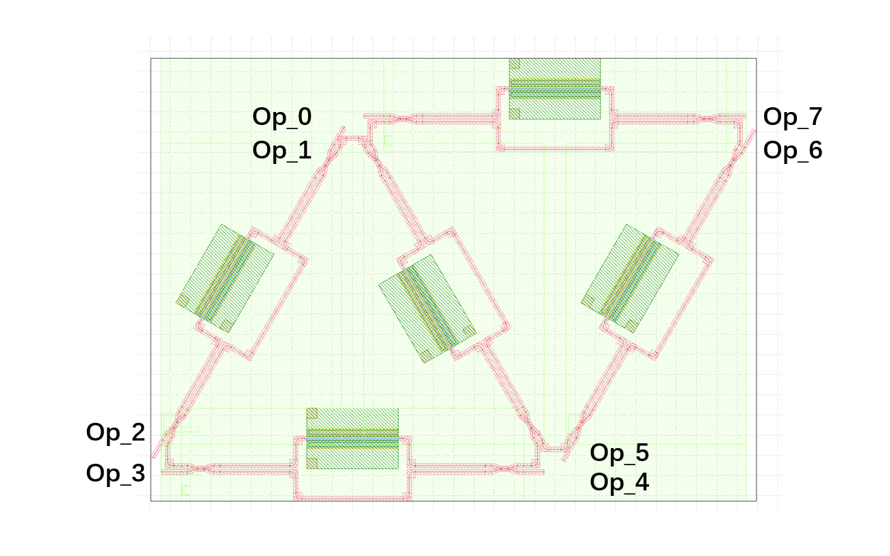

在这个Class的定义里我们并未引入光栅耦合器，需要在主函数里对光栅耦合器（或者其他类型的耦合器）进行定义；或者也可以与其他自定义的单元器件进行连接。

## 带有8个光栅耦合器的MZI Mesh（MZI_triangle_mesh_with_GC）

同样也是先导入必要的库文件：

from dataclasses import dataclass

from typing import Tuple

from fnpcell import all as fp

from gpdk.components.mzm.mzi import MZI

from gpdk.technology import WG, get_technology

from gpdk.routing.extended.extended import Extended

from gpdk.technology.waveguide_factory import EulerBendFactory

from gpdk.components.grating_coupler.grating_coupler import GratingCoupler

from gpdk.routing.comp_scan.comp_scan import CompScan,Block

随后构建MZI_triangle_mesh_with_GC类：

@dataclass(eq=False)

class MZI_triangle_mesh_with_GC(fp.PCell, band="C"):

"""

Attributes:

p_width: defaults to 1

n_width: defaults to 1

np_offset: defaults to 0

wg_length: defaults to 25

arm_spacing: defaults to 100

dc_length: defaults to 100

waveguide_type: type of waveguide

pn_phase_shifter: instance of `PnPhaseShifter`, port_count=2, pin_count=2, required=False

straight_waveguide: instance of `Straight`, port_count=2, required=False

directional_coupler_left: instance of `DirectionalCouplerSBend`, port_count=2, required=False

directional_coupler_right: instance of `DirectionalCouplerSBend`, port_count=2, required=False

port_names: defaults to ["op_0", "op_1", "op_2", "op_3"]

Examples:

```python

TECH = get_technology()

mzi = MZI(wg_length=600, waveguide_type=TECH.WG.FWG.C.WIRE)

fp.plot(mzi)

```

![MZI](images/mzi.png)

"""

side_length: float = fp.PositiveFloatParam(default=400)

dc_length: float = fp.FloatParam(default=100)

arm_spacing: float = fp.FloatParam(default=60)

wg_length: float = fp.FloatParam(default=100)

gc_spacing: float = fp.FloatParam(default=50)

waveguide_type: WG.FWG.C = fp.WaveguideTypeParam(type=WG.FWG.C)

MZI_unit: fp.IDevice = fp.DeviceParam(type=MZI, port_count=4, required=False)

grating_coupler: fp.IDevice = fp.DeviceParam(type=GratingCoupler, port_count=1, required=False)

def _default_waveguide_type(self):

return get_technology().WG.FWG.C.WIRE

def _default_MZI_unit(self):

return MZI(waveguide_type=self.waveguide_type, arm_spacing=self.arm_spacing,

dc_length=self.dc_length, wg_length=self.wg_length)

def _default_grating_coupler(self):

return GratingCoupler(waveguide_type=self.waveguide_type)

def build(self) -> Tuple[fp.InstanceSet, fp.ElementSet, fp.PortSet]:

insts, elems, ports = super().build()

# fmt: off

waveguide_type = self.waveguide_type

port_names = self.port_names

MZI_0 = self.MZI_unit.translated(0,0)

MZI_1 = self.MZI_unit.rotated(degrees=120).translated(self.side_length / 4, self.side_length / 4 * (3) ** (0.5))

MZI_2 = self.MZI_unit.rotated(degrees=60).translated(-self.side_length / 4, self.side_length / 4 * (3) ** (0.5))

MZI_3 = self.MZI_unit.translated(self.side_length / 2, self.side_length / 2 * (3) ** (0.5))

MZI_4 = self.MZI_unit.rotated(degrees=60).translated(self.side_length * 3 / 4, self.side_length / 4 * (3) ** (0.5))

gc_0 = self.grating_coupler.rotated(degrees=180).translated(-self.side_length / 4 * 3, -self.gc_spacing)

gc_1 = self.grating_coupler.rotated(degrees=180).translated(-self.side_length / 4 * 3, 10)

gc_2 = self.grating_coupler.rotated(degrees=180).translated(-self.side_length / 4 * 3, self.side_length / 2 * (3) ** (0.5) - 10 )

gc_3 = self.grating_coupler.rotated(degrees=180).translated(-self.side_length / 4 * 3, self.side_length / 2 * (3) ** (0.5) + self.gc_spacing)

gc_4 = self.grating_coupler.translated(-self.side_length / 4 * 3 + self.side_length * 2, -self.gc_spacing)

gc_5 = self.grating_coupler.translated(-self.side_length / 4 * 3 + self.side_length * 2, 10)

gc_6 = self.grating_coupler.translated(-self.side_length / 4 * 3 + self.side_length * 2,

self.side_length / 2 * (3) ** (0.5) - 10)

gc_7 = self.grating_coupler.translated(-self.side_length / 4 * 3 + self.side_length * 2,

self.side_length / 2 * (3) ** (0.5) + self.gc_spacing)

insts += fp.Linked(

link_type=waveguide_type,

bend_factory=self.waveguide_type.BEND_EULER,

links=[

MZI_0["op_1"] >> gc_0["op_0"],

MZI_2["op_0"] >> gc_1["op_0"],

MZI_2["op_3"] >> gc_2["op_0"],

MZI_3["op_0"] >> gc_3["op_0"],

MZI_0["op_2"] >> gc_4["op_0"],

MZI_4["op_1"] >> gc_5["op_0"],

MZI_4["op_2"] >> gc_6["op_0"],

MZI_3["op_3"] >> gc_7["op_0"],

MZI_0["op_0"] >> MZI_2["op_1"],

MZI_0["op_3"] >> MZI_1["op_0"],

MZI_1["op_1"] >> MZI_4["op_0"],

MZI_4["op_3"] >> MZI_3["op_2"],

MZI_1["op_2"] >> MZI_3["op_1"],

MZI_1["op_3"] >> MZI_2["op_2"],

],

ports=[],

)

# fmt: on

return insts, elems, ports

在这段代码包含以下几个部分：首先是进行默认参数的设置，比如波导类型、光栅耦合器类型等；随后实例化了各个单元器件，包括五个MZI和八个光栅耦合器，并且在实例化的过程中就定义好了坐标和旋转角度。在这一部分，光栅耦合器的坐标设置需微调，以避免飞线的产生。另外，在本例中，三角形网络的边长（side length）以及光栅耦合器的间隔（gc spacing）都是可调的。随后进行器件的连接（Linked）。

最后在主函数里生成gds文件：

if __name__ == "__main__":

from gpdk.util.path import local_output_file

gds_file = local_output_file(__file__).with_suffix(".gds")

library = fp.Library()

TECH = get_technology()

# =============================================================

# fmt: off

mesh = MZI_triangle_mesh_with_GC()

library += mesh

# fmt: on

# =============================================================

fp.export_gds(library, file=gds_file)

fp.plot(library)

生成的版图如下所示：

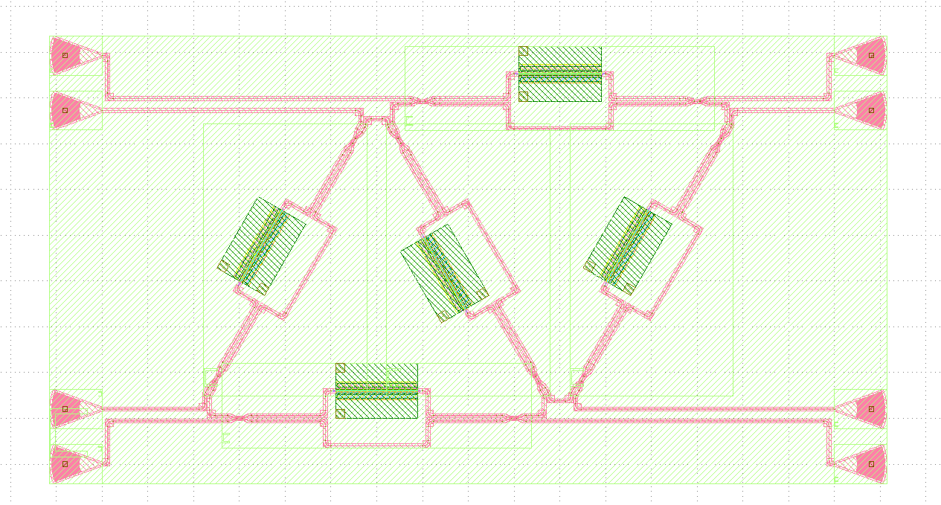 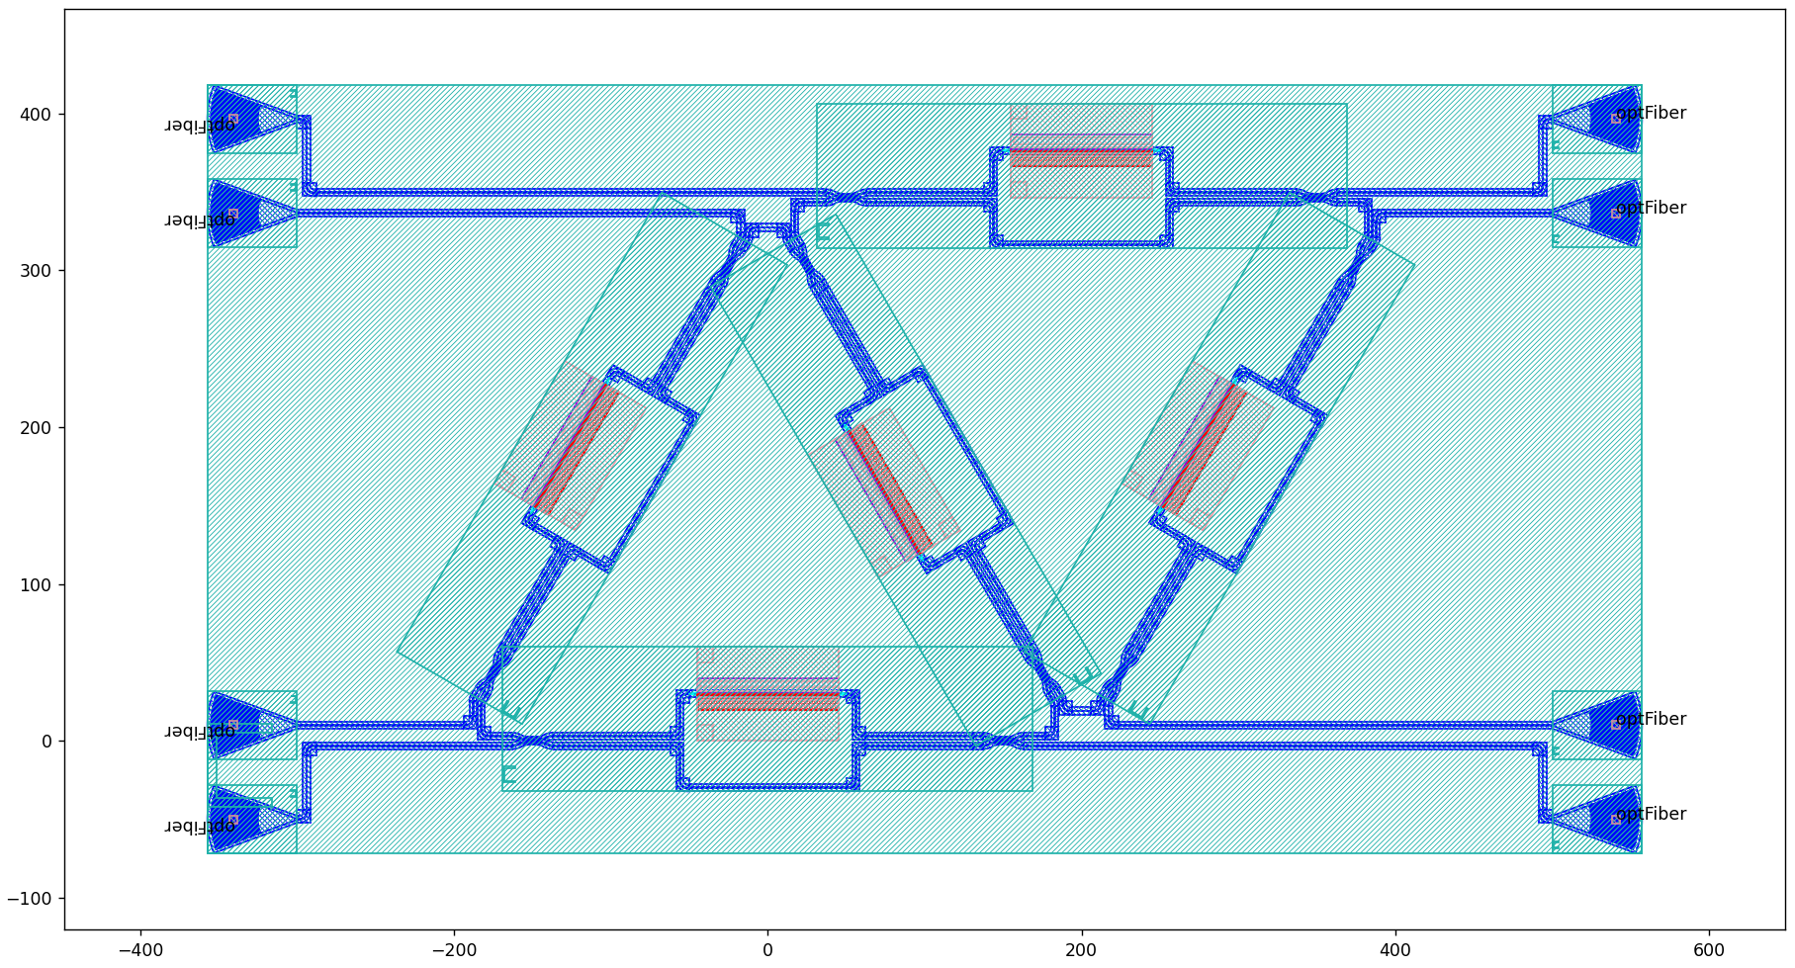  
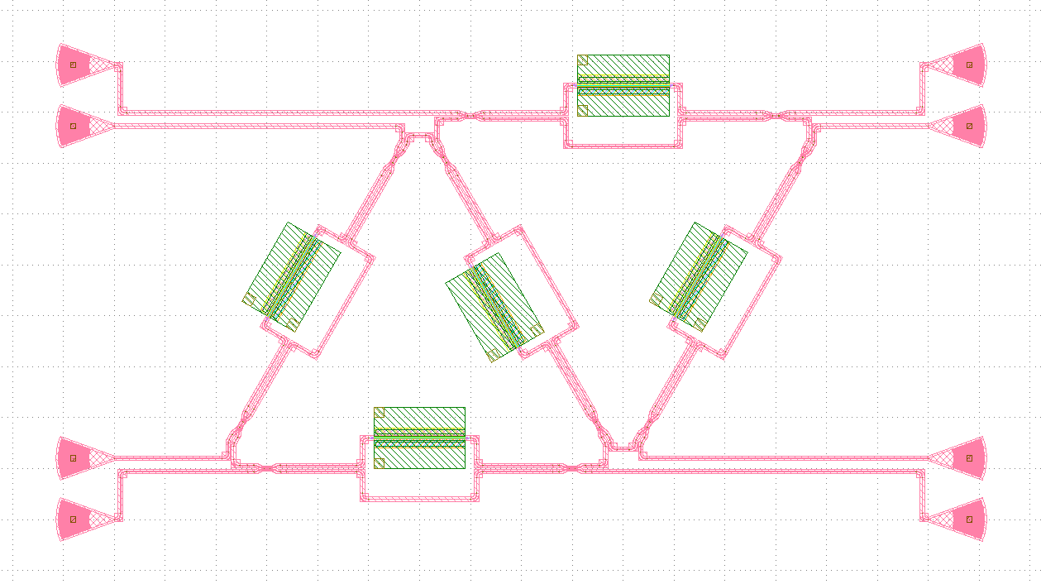

# 附录：基于comp scan进行批量化光栅耦合器连接

构建光栅耦合器的方法除了上面所讲的方法（即手动生成八个光栅耦合器，指定它们的坐标和旋转角度，最后使用Linked方法进行连接），还可以基于comp scan方法来完成。

在主函数里基于批量化函数Comp_scan可以直接自动生成8个光栅耦合器，并进行自动连接和布线：

if __name__ == "__main__":

from gpdk.util.path import local_output_file

gds_file = local_output_file(__file__).with_suffix(".gds")

library = fp.Library()

TECH = get_technology()

# =============================================================

# fmt: off

def bend_factories(waveguide_type: fp.IWaveguideType):

return TECH.WG.FWG.C.WIRE.BEND_EULER

def gc_factory(at: fp.IRay, device: fp.IDevice):

return GratingCoupler(), "op_0"

mesh = MZI_triangle_mesh()

blocks = [Block(mesh)]

library += CompScan(

name="comp_scan",

spacing=200,

width=1000,

blocks=blocks,

bend_factories=bend_factories,

waveguide_type=TECH.WG.FWG.C.WIRE,

connection_type=TECH.WG.FWG.C.WIRE,

fiber_coupler_factory=gc_factory,

)

# fmt: on

# =============================================================

fp.export_gds(library, file=gds_file)

fp.plot(library)

但这一功能仍在开发中，直接使用会出现布线交错的问题。

